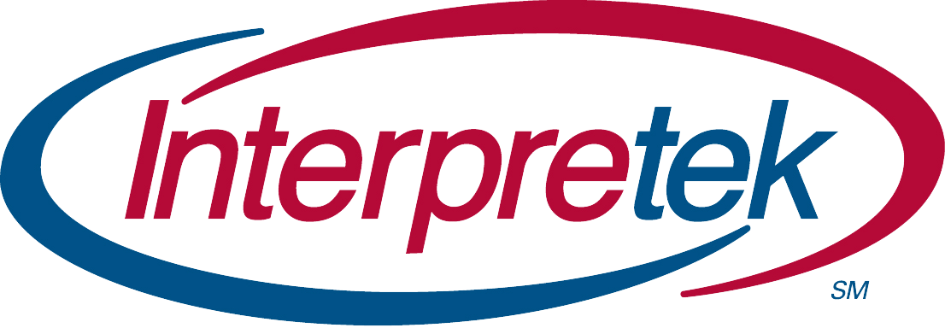
MOVIE TIME

You are invited to join a workshop for
Power Privilege and Oppression
for .6 Professional Study CEU's

October 30, 2020 to November 30, 2020

The Hammer
The Hammer, a movie based on the life of the first deaf NCAA Wrestling Champion and UFC Fighter Matt "The Hammer" Hamill. An inspirational story about wrestling, sign language, deaf culture and overcoming challenges and working hard to make your dreams a reality.

Instructions
- Contact Fran Whiteside at aslceus@gmail.com to participate.
- Free movie link will be provided.
- Group of essay questions and word count will be provided.
- Materials can be submitted any time between 10/31/20 and 11/30/20.
- No materials will be accepted after 11/30/2020 at 6 pm EST.
- Fill out the evaluation.
- When everything is completed you will receive a certification of completion.
Cost of $30
Ask about discount on a double feature!

If you have any questions please feel free to contact Fran Whiteside at aslceus@gmail.com.

